Cloud Endure DR Quick Start Guide
Steps to follow:
- Setting Up Your Account
- Signing In and Initial Configuration
- Adding Machines
- Exploring the CloudEndure User Console
- Testing and Running CloudEndure Disaster Recovery/ Live Migration/ Continuous Backup

- https://docs.cloudendure.com/Content/Installing_the_CloudEndure_Agents/Agent_Installation_Requirements/Agent_Installation_Requirements.htm

Step1: Setting Up Your Account
1.1.Navigate to your AWS Marketplace CloudEndure Disaster Recovery product page.
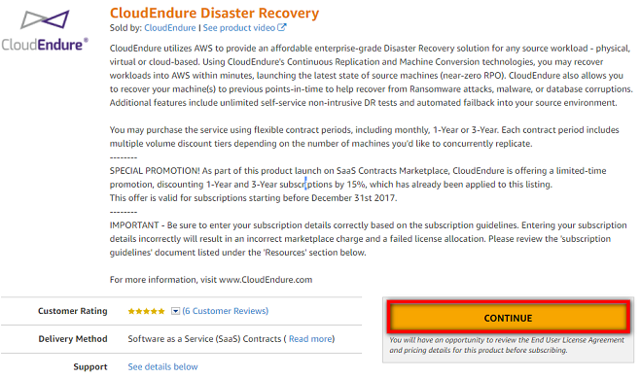

1.2.Once you have an AWS account and you are signed into AWS, return to AWS Marketplace CloudEndure Disaster Recovery page in one of the following ways:
  - Return to the introductory page of CloudEndure Disaster Recovery, and click the Continue button.
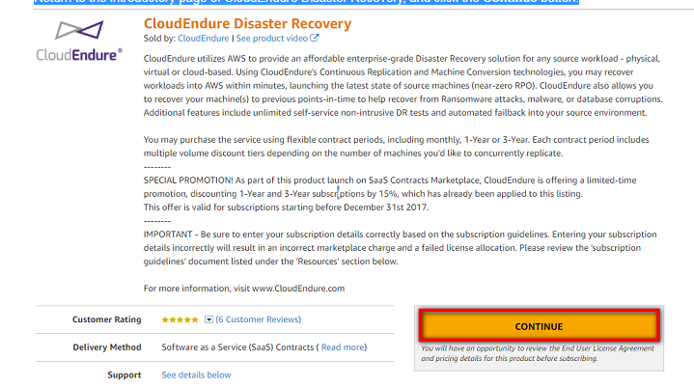

1.3. After entering the number of units you want to purchase, on the How Long do you want your contract to run section, select the period of your contract – 1 month, 12 months, or 36 months. During this time period, your Disaster Recovery solution will be active.
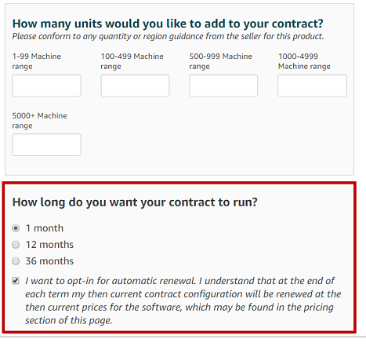
1.4.After selecting the number of replicated machines and the period of your contract, click the orange CREATE CONTRACTbutton.
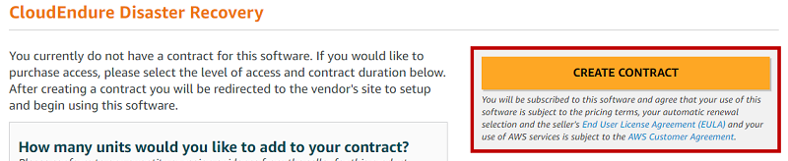

1.5. A message will appear, confirming your subscription and prompting you to set up your CloudEndure Account. Click the SET UP YOUR ACCOUNT button.
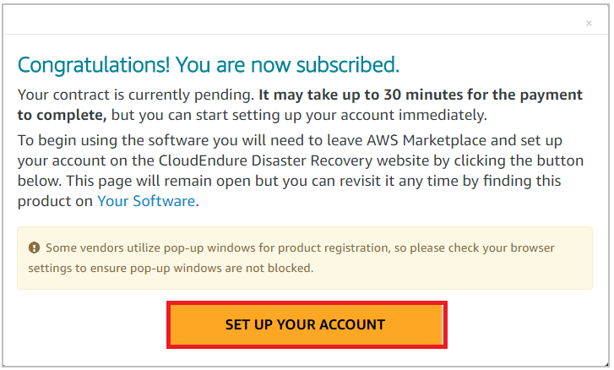
1.6. The following page will appear, indicating that a confirmation email has been sent to the email address you entered in the previous page.
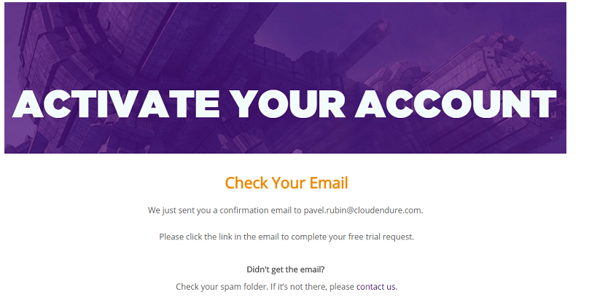

1.7. On the confirmation email you received, click the complete this form link:.
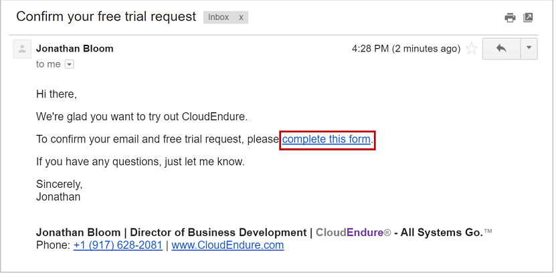
1.8. The Confirm Account Request page will appear. Fill out the form. Once the form is filled out, select the I agree to the Terms and Conditions check box, and click the Go button.

2.Signing In and Initial Configuration
Signing In
Once you are registered, you will be able to sign into the CloudEndure User Console.
2.1Working with Projects
Once signed in, you will need to either create a new Project or use an existing Project.
On the User Console, click the Plus button  on the upper left corner:
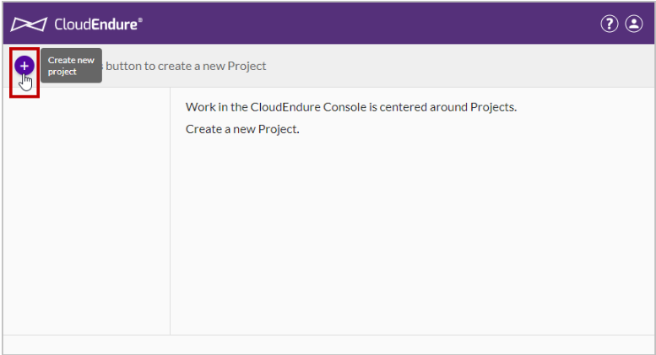

On the Create New Project dialog box, set the following, then click CREATE PROJECT.
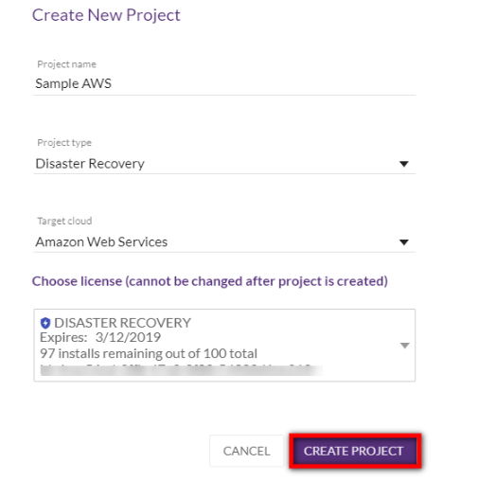
- Project name – enter a unique name for the Project. The name can contain up to 255 characters.
- Project type – select either Disaster Recovery, Live Migration, or Continuous Backup.
- Target cloud – select from the list the platform of your Target infrastructure.
- License - select a License Package to associate with your Project.
Your new Project will be created and will now appear in the Project lists on the top-left.
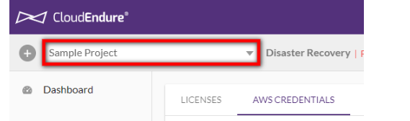
You will receive a message stating that your Project is not set up until you provide credentials and configure its Replication Settings. Click CONTINUE to dismiss the message.
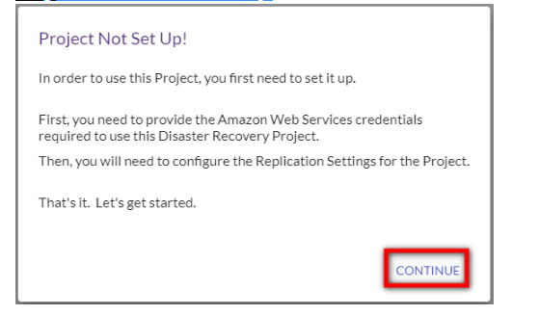
2.2 Generating and Using Your Credentials
To allow CloudEndure to connect to your AWS account for the purpose of replicating your Source machines to an AWS Target infrastructure, you need to generate AWS credentials and enter them into the CloudEndure User Console. These credentials consist of your Access key ID and a Secret access key.
1.Generating the required AWS credentials.
https://docs.cloudendure.com/Content/Generating_and_Using_Your_Credentials/Working_with_AWS_Credentials/Generating_the_Required_AWS_Credentials/Generating_the_Required_AWS_Credentials.htm
2.Using the generated AWS credentials in the CloudEndure User Console.
https://docs.cloudendure.com/Content/Generating_and_Using_Your_Credentials/Working_with_AWS_Credentials/Using_Your_AWS_Credentials/Using_Your_AWS_Credentials.htm

2.3 Defining Your Replication Settings
1. After entering your AWS credentials in the CloudEndure User Console, navigate to Setup & Info > REPLICATION SETTINGS.
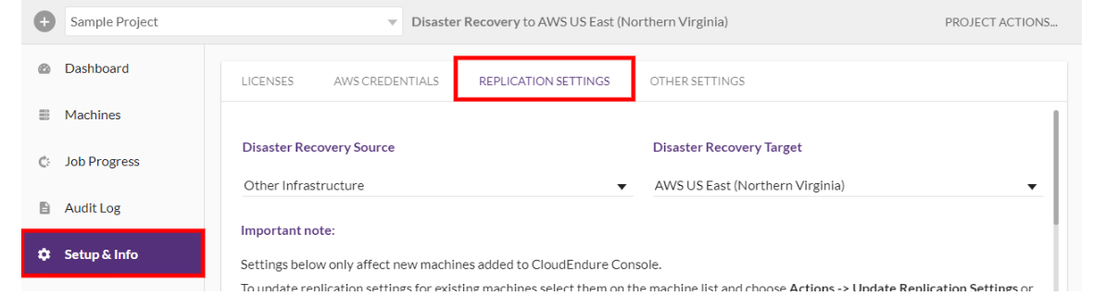
2. Next, you will need to define your Source and Target infrastructures and regions.
To define your Source infrastructure, select your current Source environment from the Disaster Recovery Source drop-down list. You can choose from the following options:
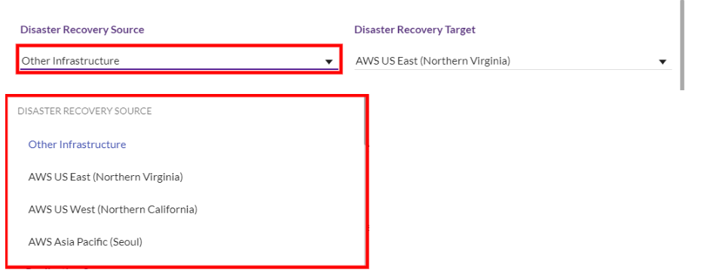
2.4Defining Your Replication Servers
After selecting your Source and Target infrastructures and regions, you will need to define your Replication Servers.
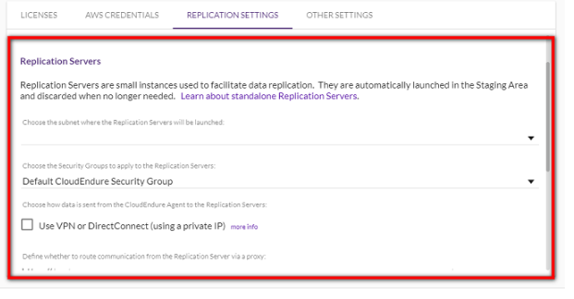
2.5Defining the Subnet
- On the Replication Servers section, set the Subnet of the Staging Area under the Choose the subnet where the Replication Servers will be launched: header.
- The Default subnet is the subnet that is allocated to you by AWS. The other subnets in the drop-down list are the subnets that are automatically allocated by AWS to the region you selected.
- Using the AWS console, you can create additional subnets in the selected region, and use them for the Staging Area. The subnets that you create via the AWS console, will appear on the Subnet drop-down list in the CloudEndure User Console.
2.6 Defining the Security Group
On the Replication Servers section, set the Security Group of the Staging Area.
The list of available Security Groups changes according to the subnet you selected in the previous field. You can add Security Groups via the AWS console, and they will appear on the Security Group drop-down list in the CloudEndure User Console.
By default, CloudEndure creates a Security Group for each Staging Area subnet. This Default CloudEndure Security Groupopens on the Staging Area the following ports:
- Inbound TCP Port 1500 for receiving the transferred replicated data.
- Outbound TCP Port 443 for communication with the CloudEndure Service Manager, the storage unit, and the AWS cloud APIs.
- [When using your own DNS server, and not an AWS server] Outbound TCP Port 53 for DNS resolution.
You can use the Default CloudEndure Security Group, or you can select another Security Group for your purposes. However, take into consideration that any selected Security Group that is not the default, will be added to the Default group, since the default Security Group is essential for the operation of your solution.
3. Adding Machines
Once your solution is completely set up, you will be able to add machines by installing the CloudEndure Agent on them. Agentscan be installed on both Linux and Windows machines.
3.1Agent Installation Requirements
Installation Requirements for Source Machines
The installation requirements for Source machines depend on the type of OS that the machine runs – either Linux or Windows.
Free disk space
Root directory - You need at least 1 GB of free disk space on the root directory of your Source machine (Windows - C:\; Linux - /) for the installation.
/tmp directory (Linux) - You need 50 MB of free disk on the /tmp directory for the duration of the installation process.
Installation Requirements for Linux Source Machines
To install Agents on machines with Linux OS, verify the following:
- Python is installed on the machine – Python 2 (2.4 or above) or Python 3 (3.0 or above).
- Verify that you have at least 1 GB of free disk on the root directory (/) of your Source machine for the installation. To check the available disk space on the root directory, run the following command: df -h /
Free disk space on the /tmp directory – for the duration of the installation process only, verify that you have at least 50 MB of free disk on the /tmp directory. To check the available disk space on the /tmp directory run the following command: df -h /tmp
After you have entered the above commands for checking the available disk space, the results will be displayed as follows:
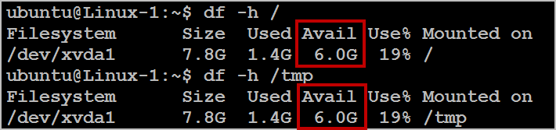
- The active bootloader software is GRUB 1 or 2.
- Ensure that sudo is installed.
- Ensure /tmp is mounted as read+write.
- /tmp is mounted with the exec option. Verify that the /tmp directory is mounted in a way that allows you to run scripts and applications from it.
To verify that the /tmp directory is mounted without the noexec option, run the following command: sudo mount | grep '/tmp'
If the result is similar to the following example, it means that the issue exits in your OS: /dev/xvda1 on /tmp type ext4 (rw,noexec)
|To fix and remove the noexec option from the mounted /tmp directory, run the following command: sudo mount -o remount,exec /tmp
The following example illustrates the troubleshooting procedure:
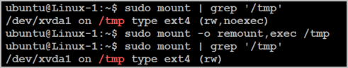
- The CloudEndure user needs to be either a root user or a user in the sudoers list.
- Ensure that dhclient package is installed. If not, please install the package. (run yum install dhclient in CMD)
- Verify that you have kernel-devel/linux-headers installed that are exactly of the same version as the kernel you are running.
The version number of the kernel headers should be completely identical to the version number of the kernel.To handle this issue, follow these steps:
    - Identify the version of your running kernel.
To identify the version of your running kernel, run the following command:
uname -r
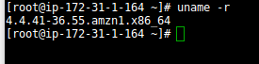
The 'uname -r' output version should match the version of one of the installed kernel headers packages (kernel-devel-<version number> / linux-headers-<version number).
    - Identify the version of your kernel-devel/linux-headers.
To identify the version of your running kernel, run the following command:
On RHEL/CENTOS/Oracle/SUSE:
rpm -qa | grep kernel
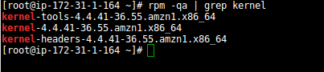
Note: This command looks for kernel-devel.
On Debian/Ubuntu: apt-cache search linux-headers
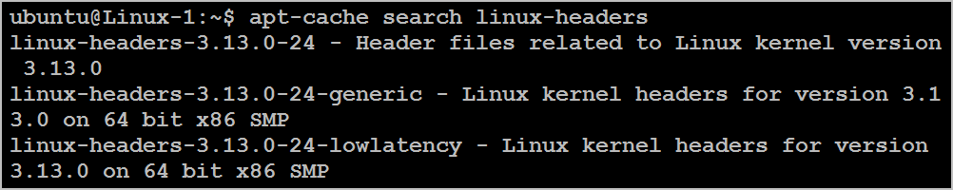
    - Verifying that the folder that contains the kernel-devel/linux-headers is not a symbolic link.
Sometimes, the content of the kernel-devel/linux-headers, which match the version of the kernel, is actually a symbolic link. In this case, you will need to remove the link before installing the required package.
To verify that the folder that contains the kernel-devel/linux-headers is not a symbolic link, run the following command:
On RHEL/CENTOS/Oracle/SUSE:
ls -l /usr/src/kernels
On Debian/Ubuntu:
ls -l /usr/src
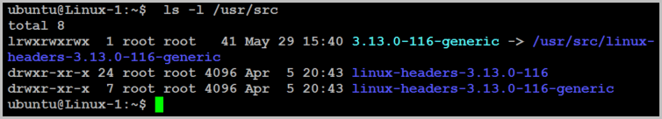
In the above example, the results show that the linux-headers are not a symbolic link.
    - [If a symbolic link exists] Delete the symbolic link.
If you found that the content of the kernel-devel/linux-headers, which match the version of the kernel, is actually a symbolic link, you need to delete the link. Run the following command: rm /usr/src/<LINK NAME>
For example: rm /usr/src/linux-headers-4.4.1
    - Install the correct kernel-devel/linux-headers from the repositories.
If none of the already installed kernel-devel/linux-headers packages match your running kernel version, you need to install the matching package.
Note: You can have several kernel headers versions simultaneously on your OS, and you can therefore safely install new kernel headers packages in addition to your existing ones (without uninstalling the other versions of the package.) A new kernel headers package does not impact the kernel, and does not overwrite older versions of the kernel headers.
Note: For everything to work, you need to install a kernel headers package with the exact sameversion number of the running kernel.
To install the correct kernel-devel/linux-headers, run the following command:
On RHEL/CENTOS/Oracle/SUSE:
sudo yum install kernel-devel-`uname -r`
On Debian/Ubuntu:
sudo apt-get install linux-headers-`uname -r`
    - [If no matching package was found] Download the matching kernel-devel/linux-headers package.
If no matching package was found on the repositories configured on your machine, you can download it manually from the Internet and then install it.
To download the matching kernel-devel/linux-headers package, navigate to the following sites:
      - RHEL, CENTOS, Oracle, and SUSE package directory
      - Debian package directory
      - Ubuntu package directory

Installation Requirements for Windows Source Machines
To install Agents on machines with Windows OS, verify the following:
- (For replicating machines to AWS cloud only) - .NET Framework version 3.5 or above is installed on the machine.
- (For replicating machine to GCP cloud only) – if the source machine is Windows 2003 SP2 or Windows 2003 R2 (Windows 2003 SP1 is not supported), installation of unsigned drivers needs to be supported:
  - Right-click on My Computer.
  - Select Properties to open System Properties.
  - In the System Properties dialog box, select the Hardware tab.
  - Click on the Driver Signing button.
  - Select Ignore - Install the software anyway and don't ask for my approval .
  - Select Make this action the system default .
  - Click OK .
3.2Installing the Agents:
CloudEndure Agent installation does not require a reboot or any interruption to the applications that are running on your Source machines.
Performing a Standard Installation

Standard Installation Workflow
The workflow of a standard installation of an Agent on a Source machine is as follows:
- Download the Agent Installer file from the CloudEndure User Console.
Note: Make sure to always download the latest version of the Agent Installer before installation rather than using a potentially outdated version that has been stored locally.
- Copy or distribute the downloaded Agent Installer file to each Source machine that you want to include in your solution.
- Run the Agent Installer file on each Source machine, either with your CloudEndure user credentials or your Installation Token.
- [Optional] Specify the disks you want to replicate.
After performing these steps, the installation will begin. Once the installation is completed successfully, the replication of the Source machine data will start automatically, and you will be able to monitor it through the CloudEndure User Console.

Installing the Agents on Linux Source Machines
- Open the CloudEndure User Console, and click the Help icon on the upper-right corner.

- From the Help menu, select the How to Add Machines option.
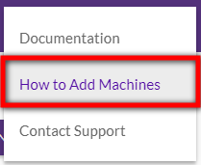
- The How To Add Instances pane will appear. To download the Agent Installer file, copy the line that includes the download command and Agent Installer file from the For Linux instances - Download the installer section.
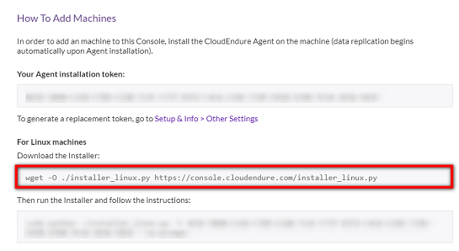
- On the Source machine, paste the command and Agent Installer file you copied, and press Enter.
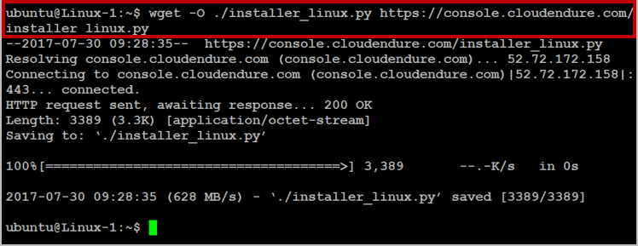
(the Installation Token is blurred in the example)
The Agent Installer will be downloaded onto your machine.
- To run the Agent Installer, copy the command that appears beneath the Agent Installer file under the Then run the Installer and follow the instructions heading. This command also contains your Installation Token.
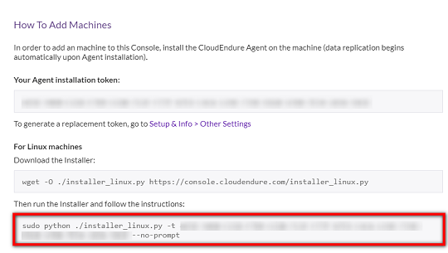
- On the Source machine, paste the copied command and press Enter.
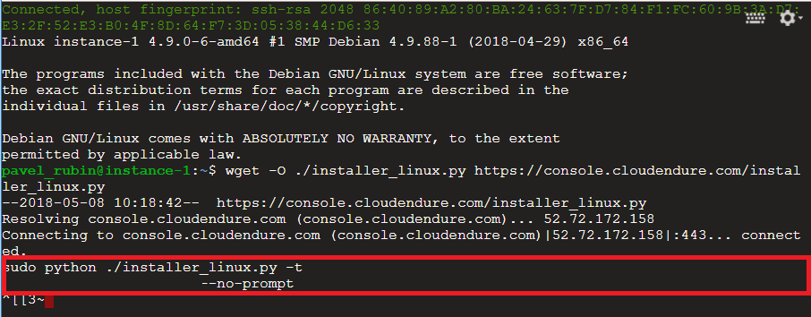
(the Installation Token is blurred in the example)
Note: You can use your user credentials instead of your Installation Token. If you are using your user credentials, you will be asked to also enter the name of the Project for which you are installing the Agent.
- Once the installation starts, the Agent Installer will automatically identify the disks of the Source machine that can be replicated. Then, it will display them with the caption - Your disks are:
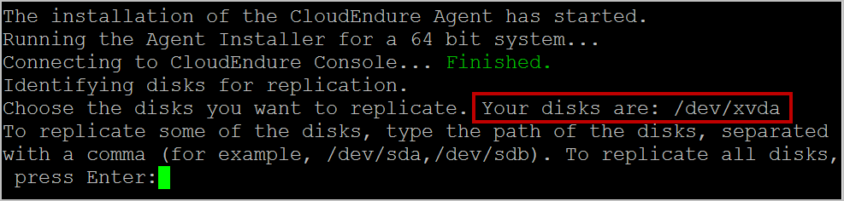
- After the list of available disks for replication is displayed, you will be asked to select the disks you want to replicate. Perform one of the following actions:
  - To replicate all the disks of the Source machine, press Enter.
  - To replicate selected disks of the Source machine, type the path of the disks you want to replicate, and separate them with a comma, as follows: /dev/sda,/dev/sdb. Then, press Enter.
Note: When typing selected disks for replication, do NOT use apostrophes, brackets, or disk paths that do not exit. Type only existing disk paths.
Important! Once disks are disconnected from a machine, CloudEndure can no longer replicate them, so they are removed from the list of replicated disks. When they are re-connected, the CloudEndure Agent cannot know that these were the same disks that were disconnected and therefore does not add them automatically.
To add the disks after they are connected again, please run the CloudEndure Agent Installer on the machine. Note that the returned disks will need be replicated from scratch.
- After pressing Enter, the installation of the Agent on the Source machine will start.
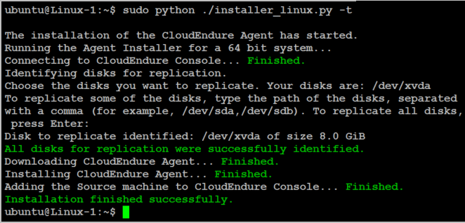
Note: Each disk you selected for replication is displayed with the caption Disk to replicate identified. However, the displayed list of identified disks for replication may differ from the data you entered. This difference can due to two reasons:
  - The root disk of the Source machine is always replicated, whether you select it or not, since it is required for the launching of the Target machine. Therefore, it always appears on the list of identified disks for replication.
  - CloudEndure replicates whole disks. Therefore, if you choose to replicate a partition, its entire disk will appear on the list and will later be replicated. If several partitions on the same disk are selected, then the disk encompassing all of them will only appear once on the list.

- Once the Agent installation is completed successfully, the Source machine will appear in the CloudEndure User Console, and the initial replication process will begin.
Note: When replication starts, you will first see the replication initiation steps in the DATA REPLICATION PROGRESS column within the Machines tab of the CloudEndure User Console. Once all the steps are completed successfully, the actual Data Replication begins.
The machine will undergo a variety of steps, including Creating Firewall Rules, Creating Replication Server, Booting Replication Server, Resolving Management Server Address, Authenticating with Management Server, Downloading Replication Software, Creating Replication Disks, Pairing Replication Server with Agent, and Establishing Agent Replication Server Communication.
Once the initial sync and Data Replication are complete, the DATA REPLICATION PROGRESS bar will show Continuous Data Protection (DR/Backup) or Continuous Data Replication (LM).
Note: There are cases where there is no progress in the DATA REPLICATION PROGRESS column. This type of issue can be manifested in two ways:
  - The message in the DATA REPLICATION PROGRESS column appears in red, and in the STATUS column a red icon is shown. This usually means that there is a connectivity problem.
In this case, verify that all the network requirements are met.
  - The message Establish communication between the CloudEndure Agent and the Replication Server does not appear in red, but is displayed for more than 5 minutes, and the red icon is not displayed. This usually means that the Agent failed to run or that the Agent never established communication with the User Console:
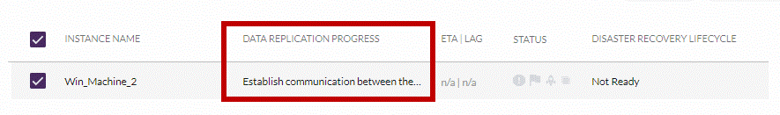

Installing the Agents on Windows Source Machines
You should install the Agent, using the Agent Installer file, on each Windows Source machine that you want to include in your Migration/Disaster/Backup Recovery solution.
Important! You need to run the Agent Installer file as an Administrator on each Windows machine.
- Open the CloudEndure User Console, and click the Help icon on the upper-right corner.
- From the Help menu, select the How to Add Machines option.
- The How To Add Instances pane will appear. Click the Download the Windows installer link at the bottom of the pane under the For Windows instances header.
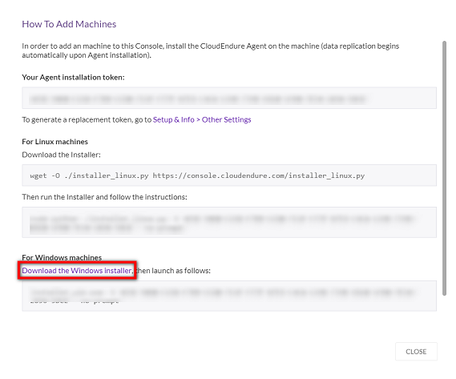
- The Agent Installer will be downloaded to your machine. Copy or distribute the downloaded Agent Installer to each Source machine you want to include in your solution.
- Run the Agent Installer file - installer_win.exe - as an Administrator.
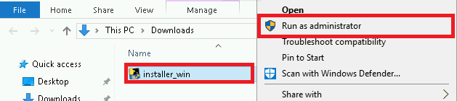
- The CMD will open, where you will be prompted to enter your CloudEndure user credentials or your Installation Token.
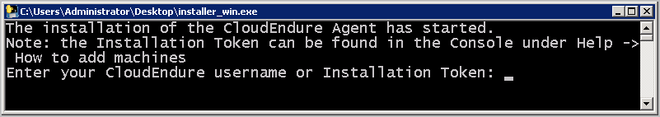
Note: We recommend installing Agents through the use of the Installation Token and not your CloudEndure username, password and Project name, as it is a significantly quicker and more comfortable process.
- In CMD, enter one of the following and then press Enter.
  - Your CloudEndure username.
  - Installation Token – your Installation Token, as it appears in the Consolewith the parameters specified under the For Windows machines header after the download link. If you are entering a token, you will not be asked to enter a password. In this case, skip to Step 10 below.
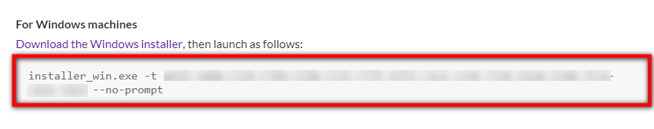
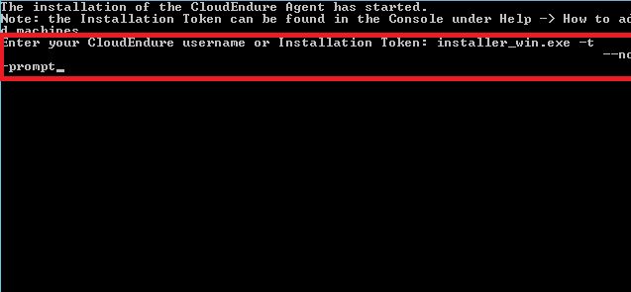
(the Installation Token is blurred in the example)
Note: To find your unique Installation Token, see the previous Locating a Project Token section.
- If you entered your CloudEndure username, you will be asked to enter your password. Type the password and press Enter.
Note: Your CloudEndure password is the password you use to sign into the User Console.
Note: If you did not enter the correct details or made a typo, you will not be able to procced with the installation. You will receive a message informing you that the installation was not finished successfully:
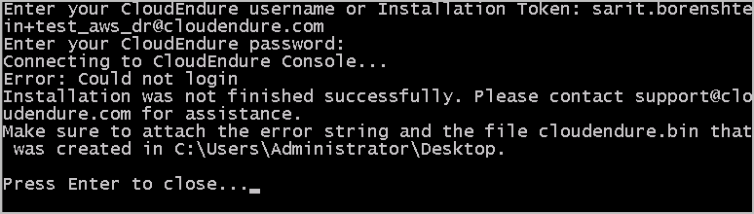
In this case, press Enter. After the CMD is closed, re-run the installer_win.exe file and repeat the process from the start.
- If you are using your user credentials, you will then be asked to enter the name of the Project for which you are installing the Agent.
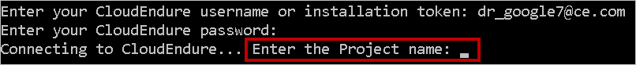
Type the Project name and press Enter.
- Once your CloudEndure credentials or Installation Token are confirmed, the Agent Installer will automatically start identifying the disks of the Source machine that can be replicated. Then, it will display them with the caption - Your disks are:
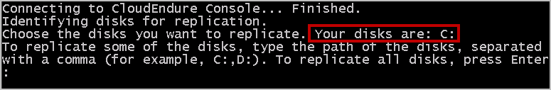
Note: If you selected a specific AWS region as your Source region on the Replication Settings page and your Target infrastructure is also an AWS region, the Agent Installer will also automatically identify the disks of the Source machine that can be replicated. However, it will not display the disk list, and it will automatically replicate all disks. You will receive the following message: All disks for replication were successfully identified. Then, the installation of the Agent on the Source machine will begin.
Important! Once disks are disconnected from a machine, CloudEndure can no longer replicate them, so they are removed from the list of replicated disks. When they are re-connected, the CloudEndure Agent cannot know that these were the same disks that were disconnected and therefore does not add them automatically.
To add the disks after they are connected again, please run the CloudEndure Agent Installer on the machine. Note that the returned disks will need be replicated from scratch.
- After the list of available disks for replication is displayed, you will be asked to select the disks you want to replicate. Perform one of the following actions:
  - To replicate all the disks of the Source machine, press Enter.
  - To replicate selected disks of the Source machine, type the letters of the disks you want to replicate, and separate them with a comma, as follows: C:,D:,E: Then, press Enter.
Note: When typing selected disks for replication, do NOT use apostrophes, brackets, disk names, or disk letters that does not exit. Type only existing disk letters.
After pressing Enter, the installation of the Agent on the Source machine will begin.
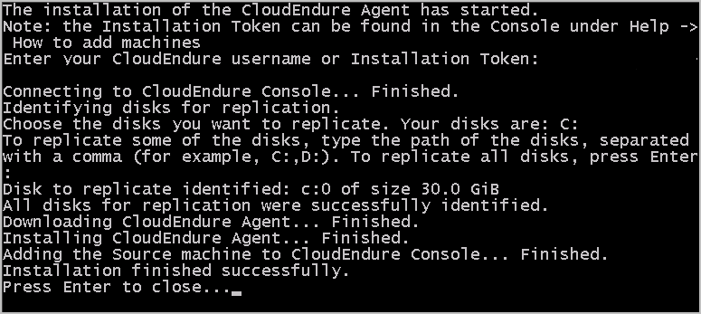
Note: Each disk that you select for replication is displayed with the caption Disk to replicate identified. However, the list of identified disks for replication may differ from the data you entered. This difference can be caused by two reasons:
    - The root disk of the Source machine is always replicated, whether you select it or not, since it is required for the launch of the Target machine. Therefore, it will always appear on the list of identified disks for replication.
    - CloudEndure replicates whole disks. If you chose to replicate a partition, its entire disk will be replicated. In Windows, a disk is identified by the disk letter of the first partition. Therefore, only the first partition will appear on the list, but all other partitions will be replicated as well.
- Once the Agent installation is completed successfully, the Source machine will appear in the CloudEndure User Consoleunder the Machines category, and the initial replication process will begin.
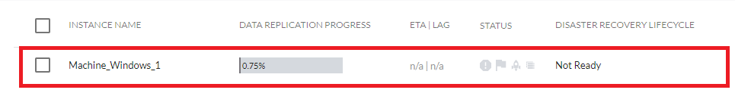
Note: When the replication starts, you will first see the replication initiation steps in the DATA REPLICATION PROGRESS column within the Machines tab of the CloudEndure User Console. Once all the steps are completed successfully, the actual Data Replication will begin.
The machine will undergo a variety of steps, including Creating Firewall Rules, Creating Replication Server, Booting Replication Server, Resolving Management Server Address, Authenticating with Management Server, Downloading Replication Software, Creating Replication Disks, Pairing Replication Server with Agent, and Establishing Agent Replication Server Communication.
Once the initial sync and Data Replication are complete, the DATA REPLICATION PROGRESS bar will show Continuous Data Protection (DR/Backup) or Continuous Data Replication (LM).
Note: There are cases where there is no progress in the DATA REPLICATION PROGRESS column. This type of issue can be manifested in two ways:
  - The message in the DATA REPLICATION PROGRESS column appears in red, and in the STATUS column a red icon is shown. This usually means that there is a connectivity problem.
In this case, verify that all the network requirements are met.
  - The message Establish communication between the CloudEndure Agent and the Replication Server does not appear in red, but is displayed for more than 5 minutes, and the red icon is not displayed. This usually means that the Agent failed to run or that the Agent never established communication with the User Console:
In this case, follow the troubleshooting steps described in the Error: Agent is not Running Properly section.
4.Exploring the CloudEndure User Console
Once you have added your machines, you can explore the full functionality of the CloudEndure User Console. Ensure that you fully understand the functionality of the Machines page, which is key to using your solution and the Setup & Info page, which contains all of your Project settings.
Exploring the CloudEndure User Console-https://docs.cloudendure.com/Content/Getting_Started_with_CloudEndure/Exploring_the_CloudEndure_Console/Exploring_the_CloudEndure_Console.htm
5.Testing and Running Disaster Recovery
Once your Project is set up, your machines are installed, and you know how to utilize the User Console, you can begin to configure and run your Disaster Recovery, Live Migration, or Continuous Backup solution. This includes launching Target machines for your Source machines and performing the Restore (DR), Backup (Backup), and Cutover (LM) actions.

Configuring and Running Disaster Recovery
This section includes a complete overview of the CloudEndure Disaster Recovery process, including planning your Disaster Recovery project, an explanation of the Disaster Recovery process workflow, an overview of Disaster Recovery states, testing your Disaster Recovery solution, performing a Disaster Recovery Failover, and finally, initiating a Failback.
Contents
- Planning Your Disaster Recovery Project
- The Disaster Recovery Process Workflow
- Disaster Recovery Best Practices
- Exploring the Disaster Recovery States
- Configuring the Target Machine Blueprint
- Testing the Disaster Recovery Solution
- Performing a Disaster Recovery Failover
- Initiating a Failback

